Lab report 3: Modeling and PID Control

Haptic paddle modeling

A model for the *Haptic Paddle* was implemented in Simulink. To verify the model, it was compared to recorded data of the actual *Haptic Paddle* itself. For that purpose a signal generator was implemented in LabVIEW and the paddle position (hall sensor) was stored as well as the time. The position signal was filtered by a Lowpass filter for all Lab 3 exercises.

**Position Filter:**

Filter type: Butterworth Lowpass

Low cutoff frequency: 20Hz

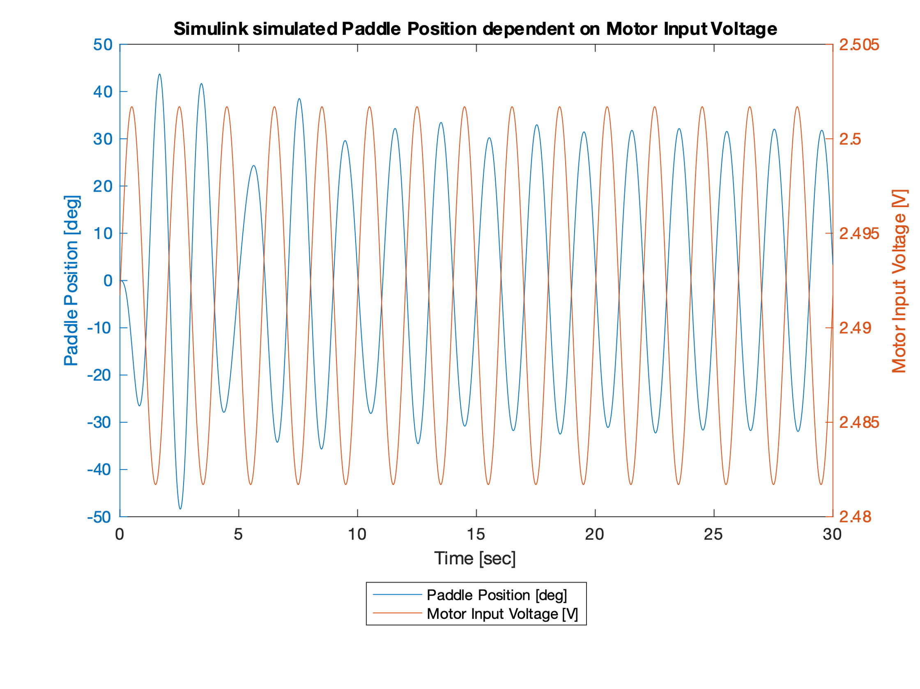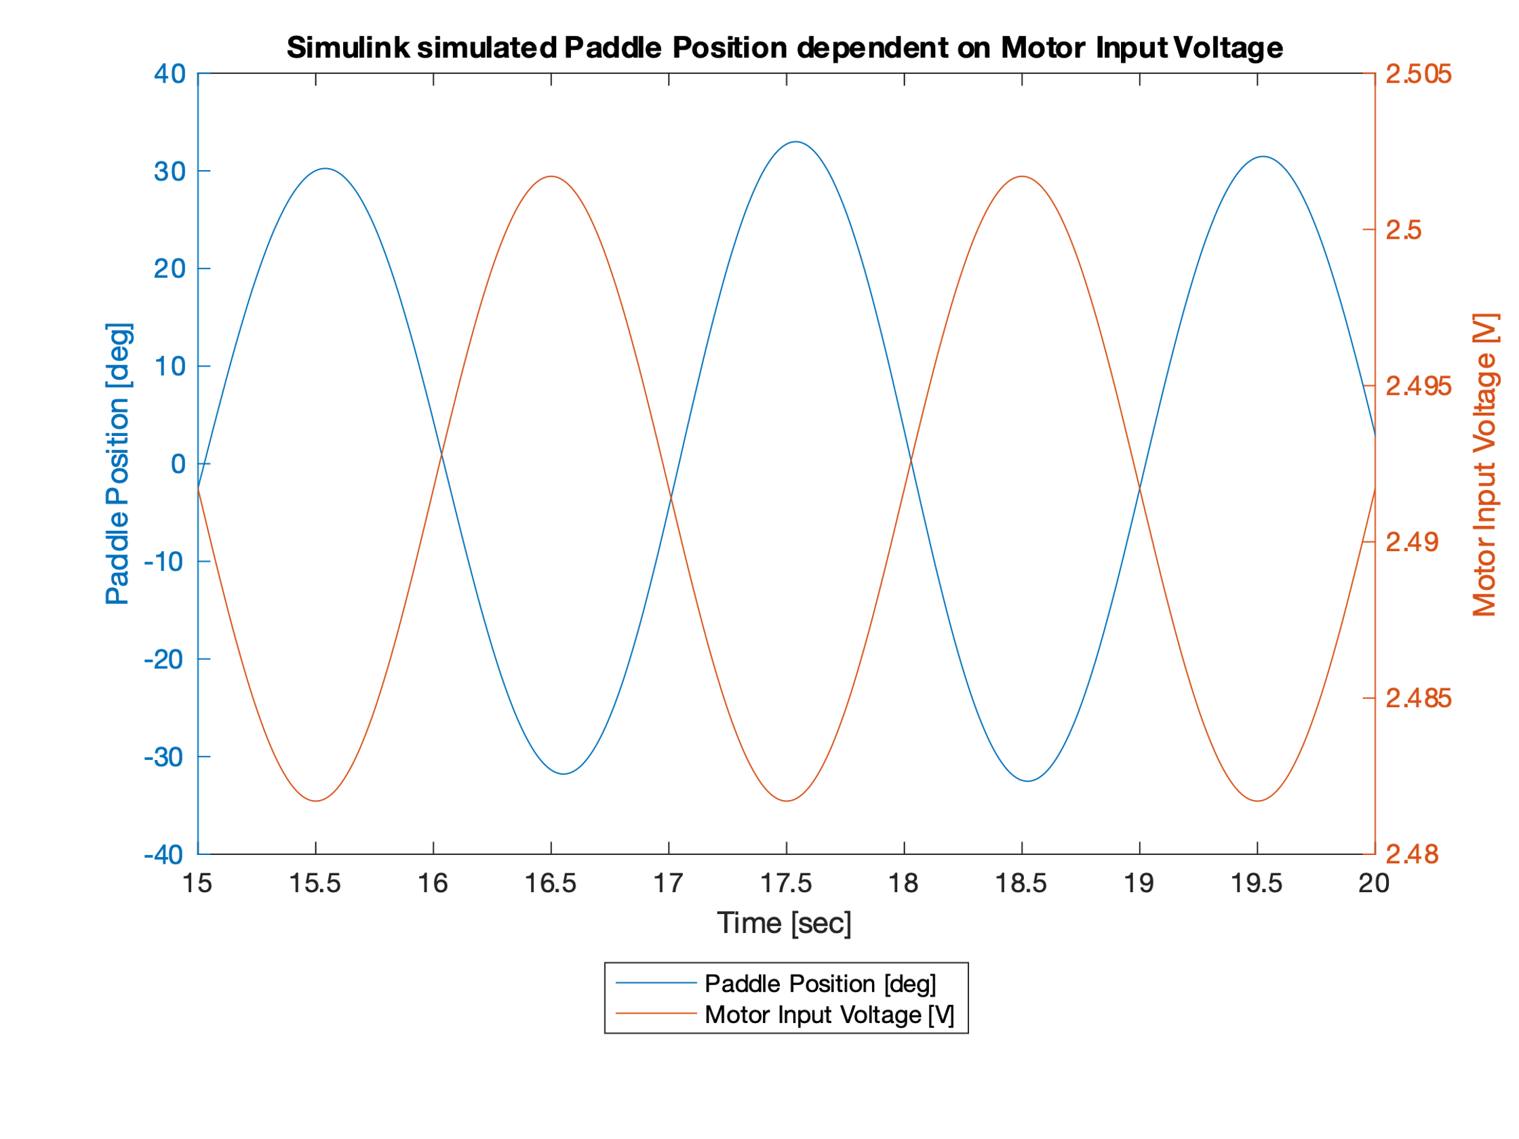

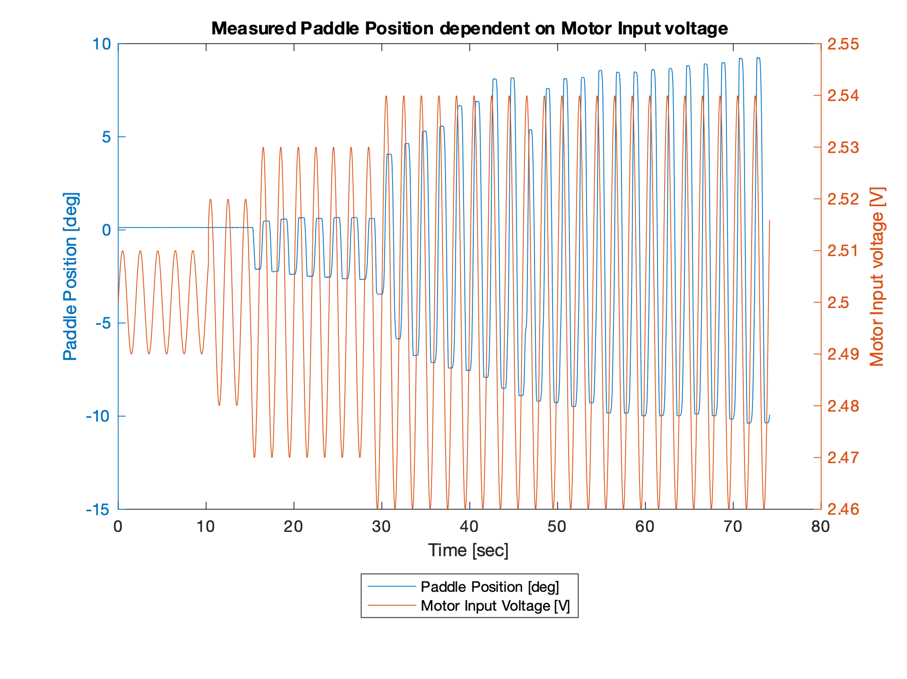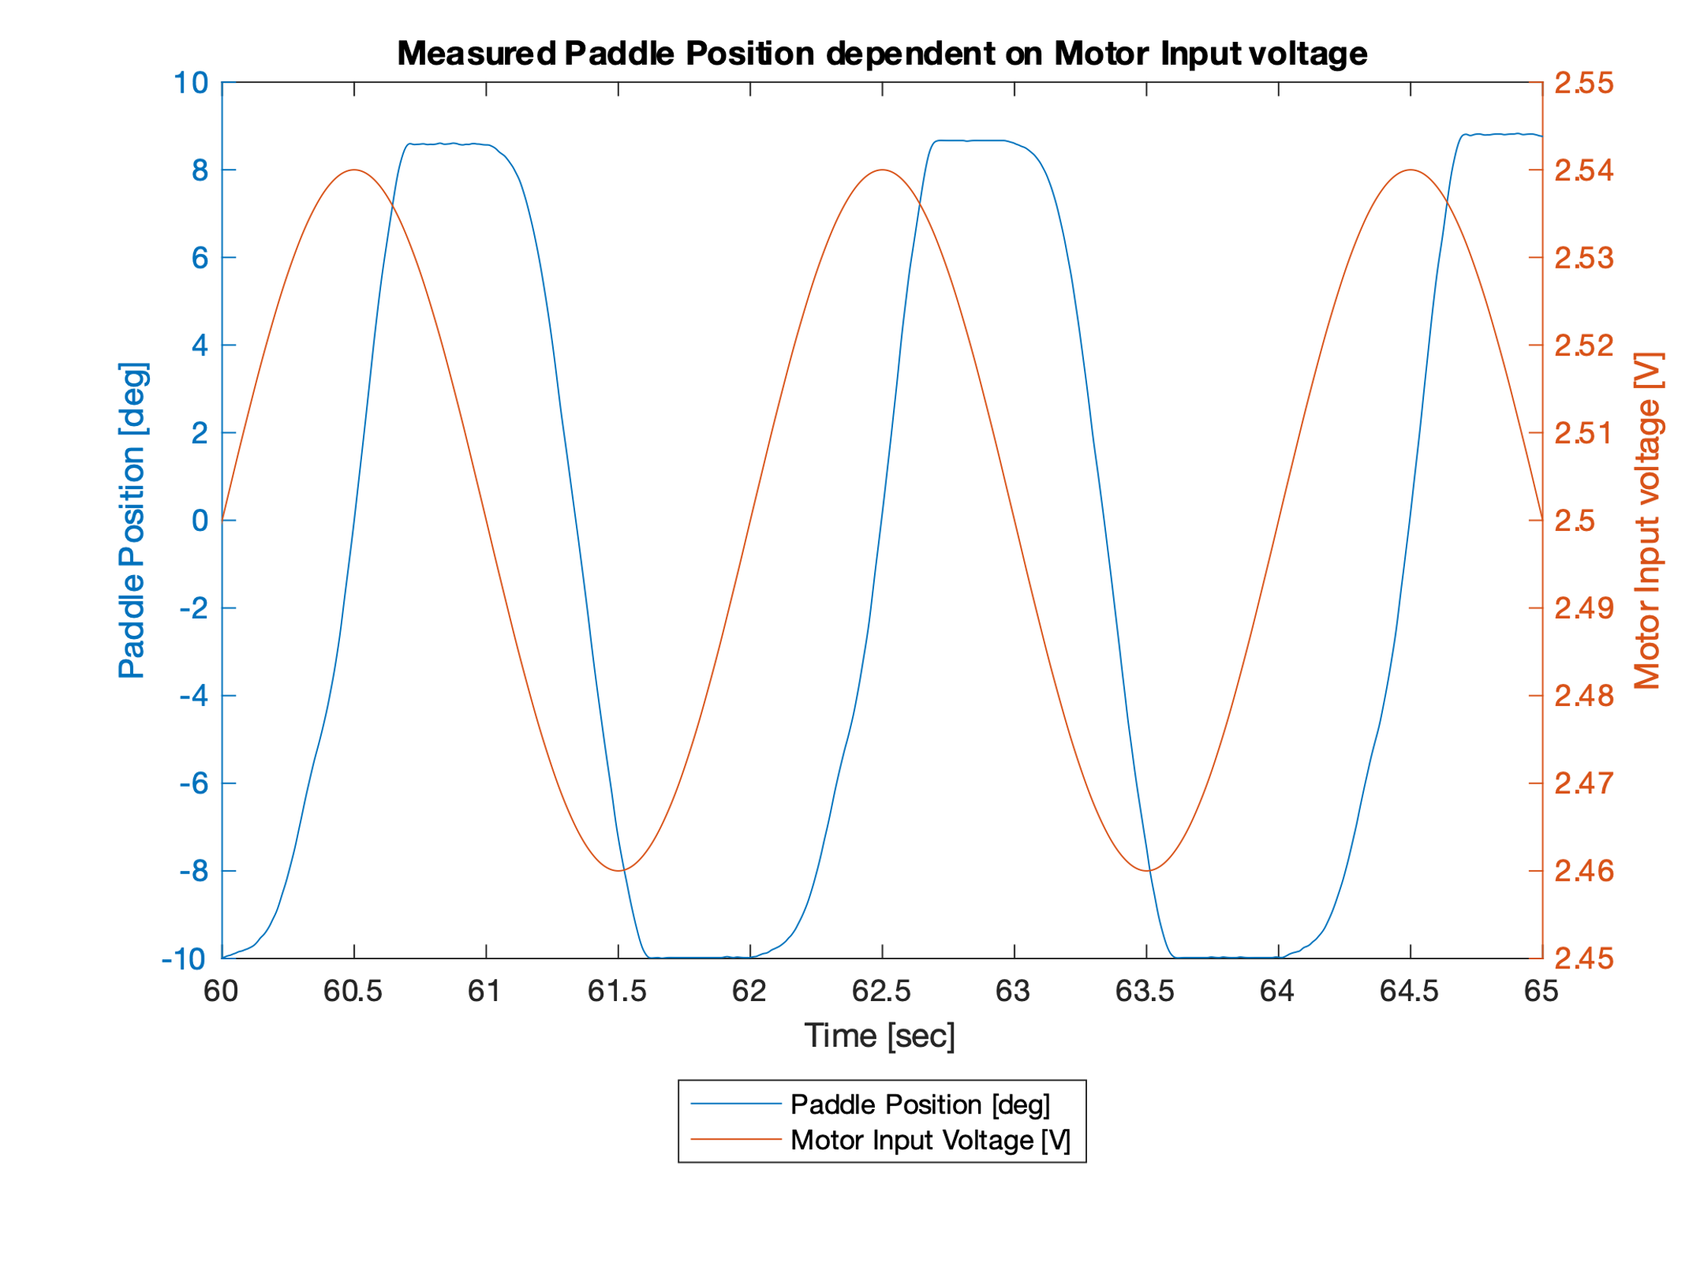

The physical paddle does need much more motor input current for a smaller amplitude in position change compared to the Simulink Model. The reason for this effect, is the static friction. The plot of our real *Haptic Paddle* also shows the unsymmetric behavior.

PID Controller

A PID controller for the *Haptic Paddle* was implemented. First the controller parameters were tuned to meet the minimum requirements for a step response (see below). After tuning the PID controller was fed with two different signals to verify its function. For verification the paddle movements were recorded (motor input voltage, position, time and video). For further development of our PID controller the D-parameter was changed to act on the process variable instead of the error (set setpoint weighting).

**Minimum requirements for a step response:**

|  |  |
| --- | --- |
| Step: | Start: 0°  End: 10° |
| Error band: | 0.4° (±0.2°) |
| Overshoot max: | 40% (4°) |
| Rise time (t90): | 100ms |
| Settling time max: | 350ms |

We defined Ku (ultimate gain) as 0.026 and the Tu (oscillation period) as 0.2 sec.

|  |  |  |
| --- | --- | --- |
| KP | 0.60 x Ku | 0.0156 |
| KI | 1.2 x Ku / Tu | 0.156 |
| KD | 3 x Ku x Tu / 40 | 0.00039 |

Tuning / Step function Plot here

**PID response on signal 1 and signal 2. D-part acts on error**

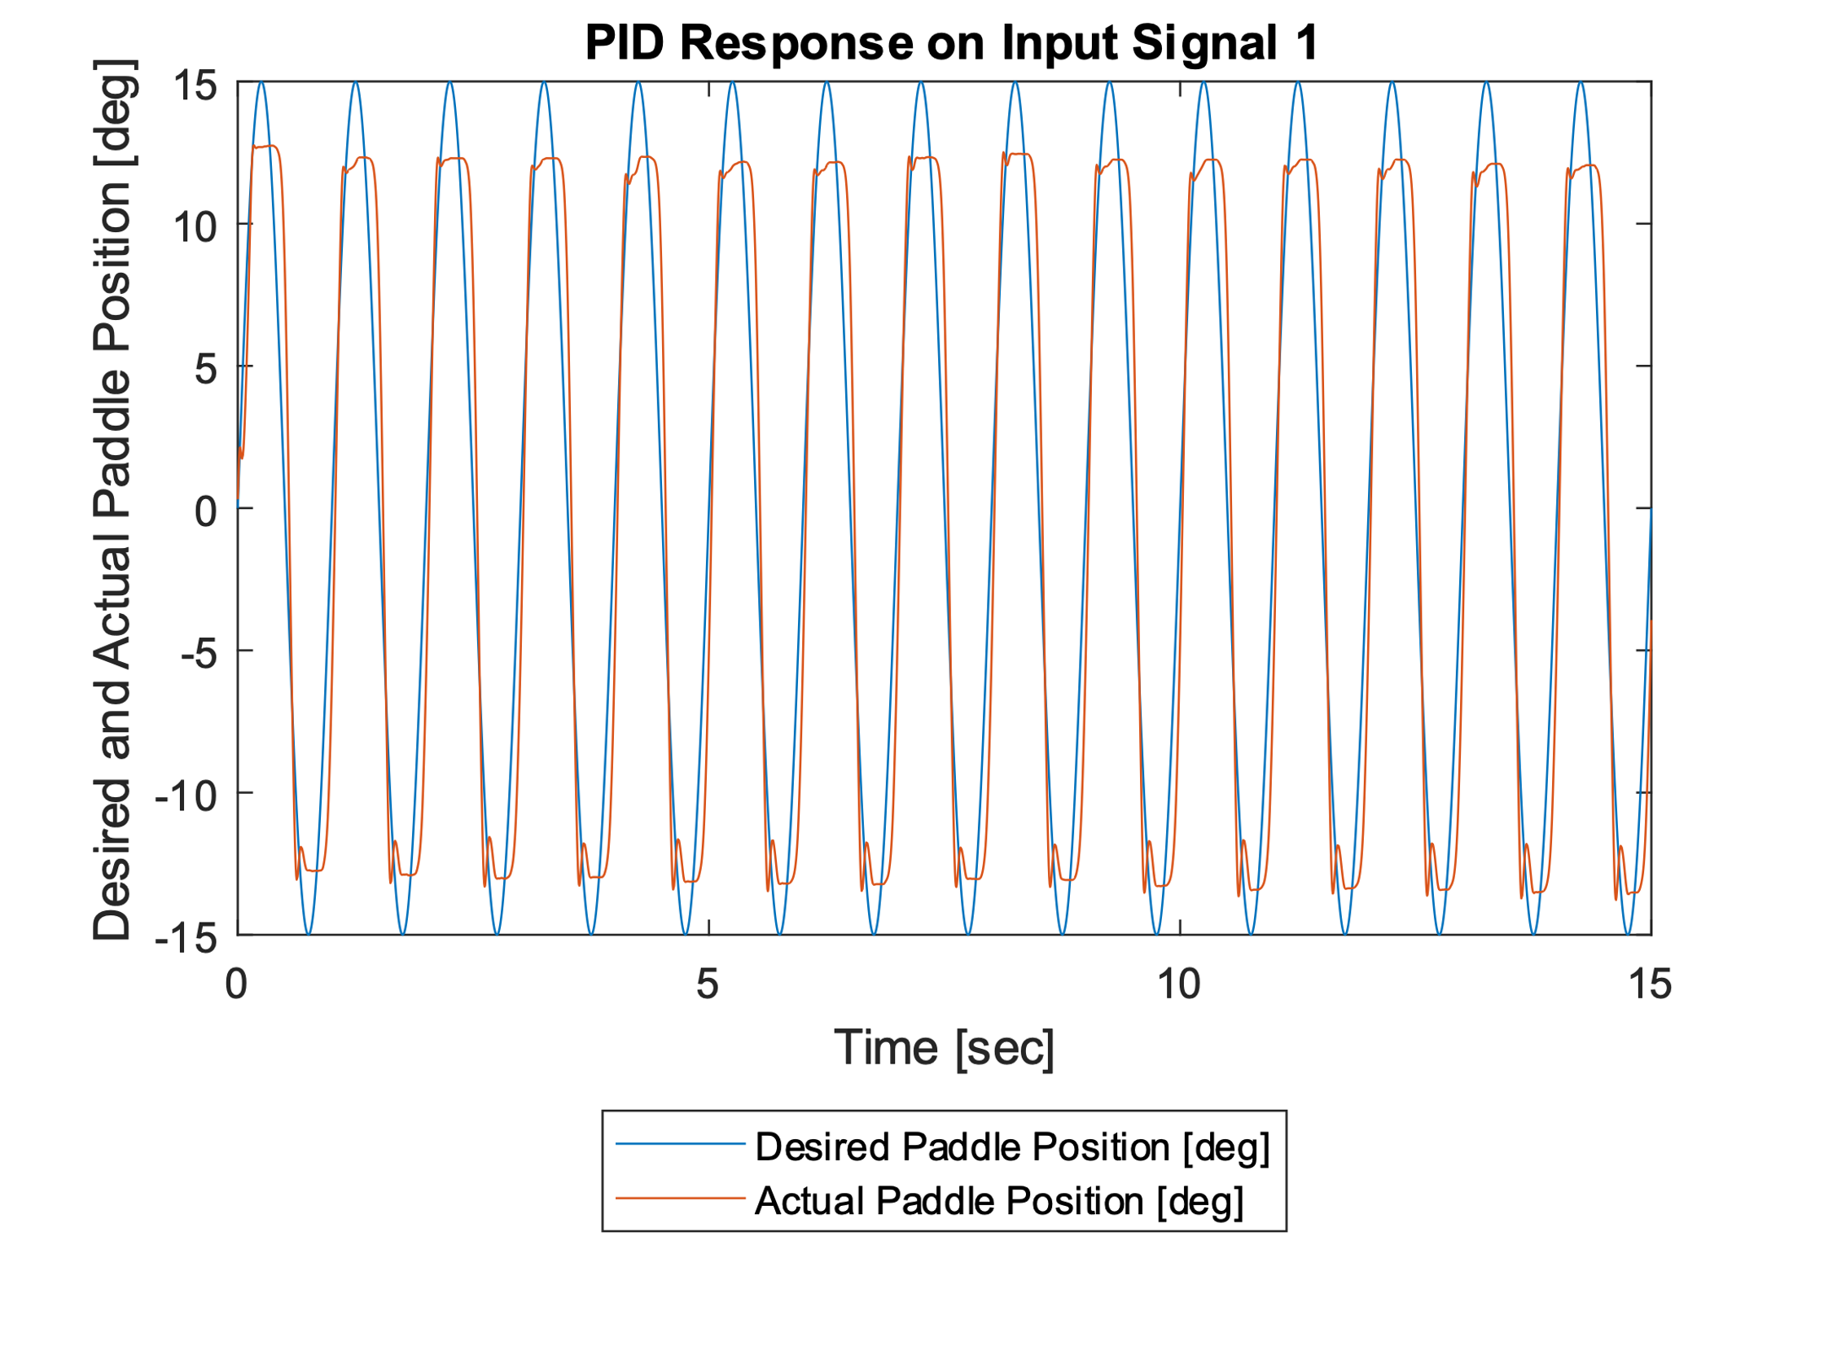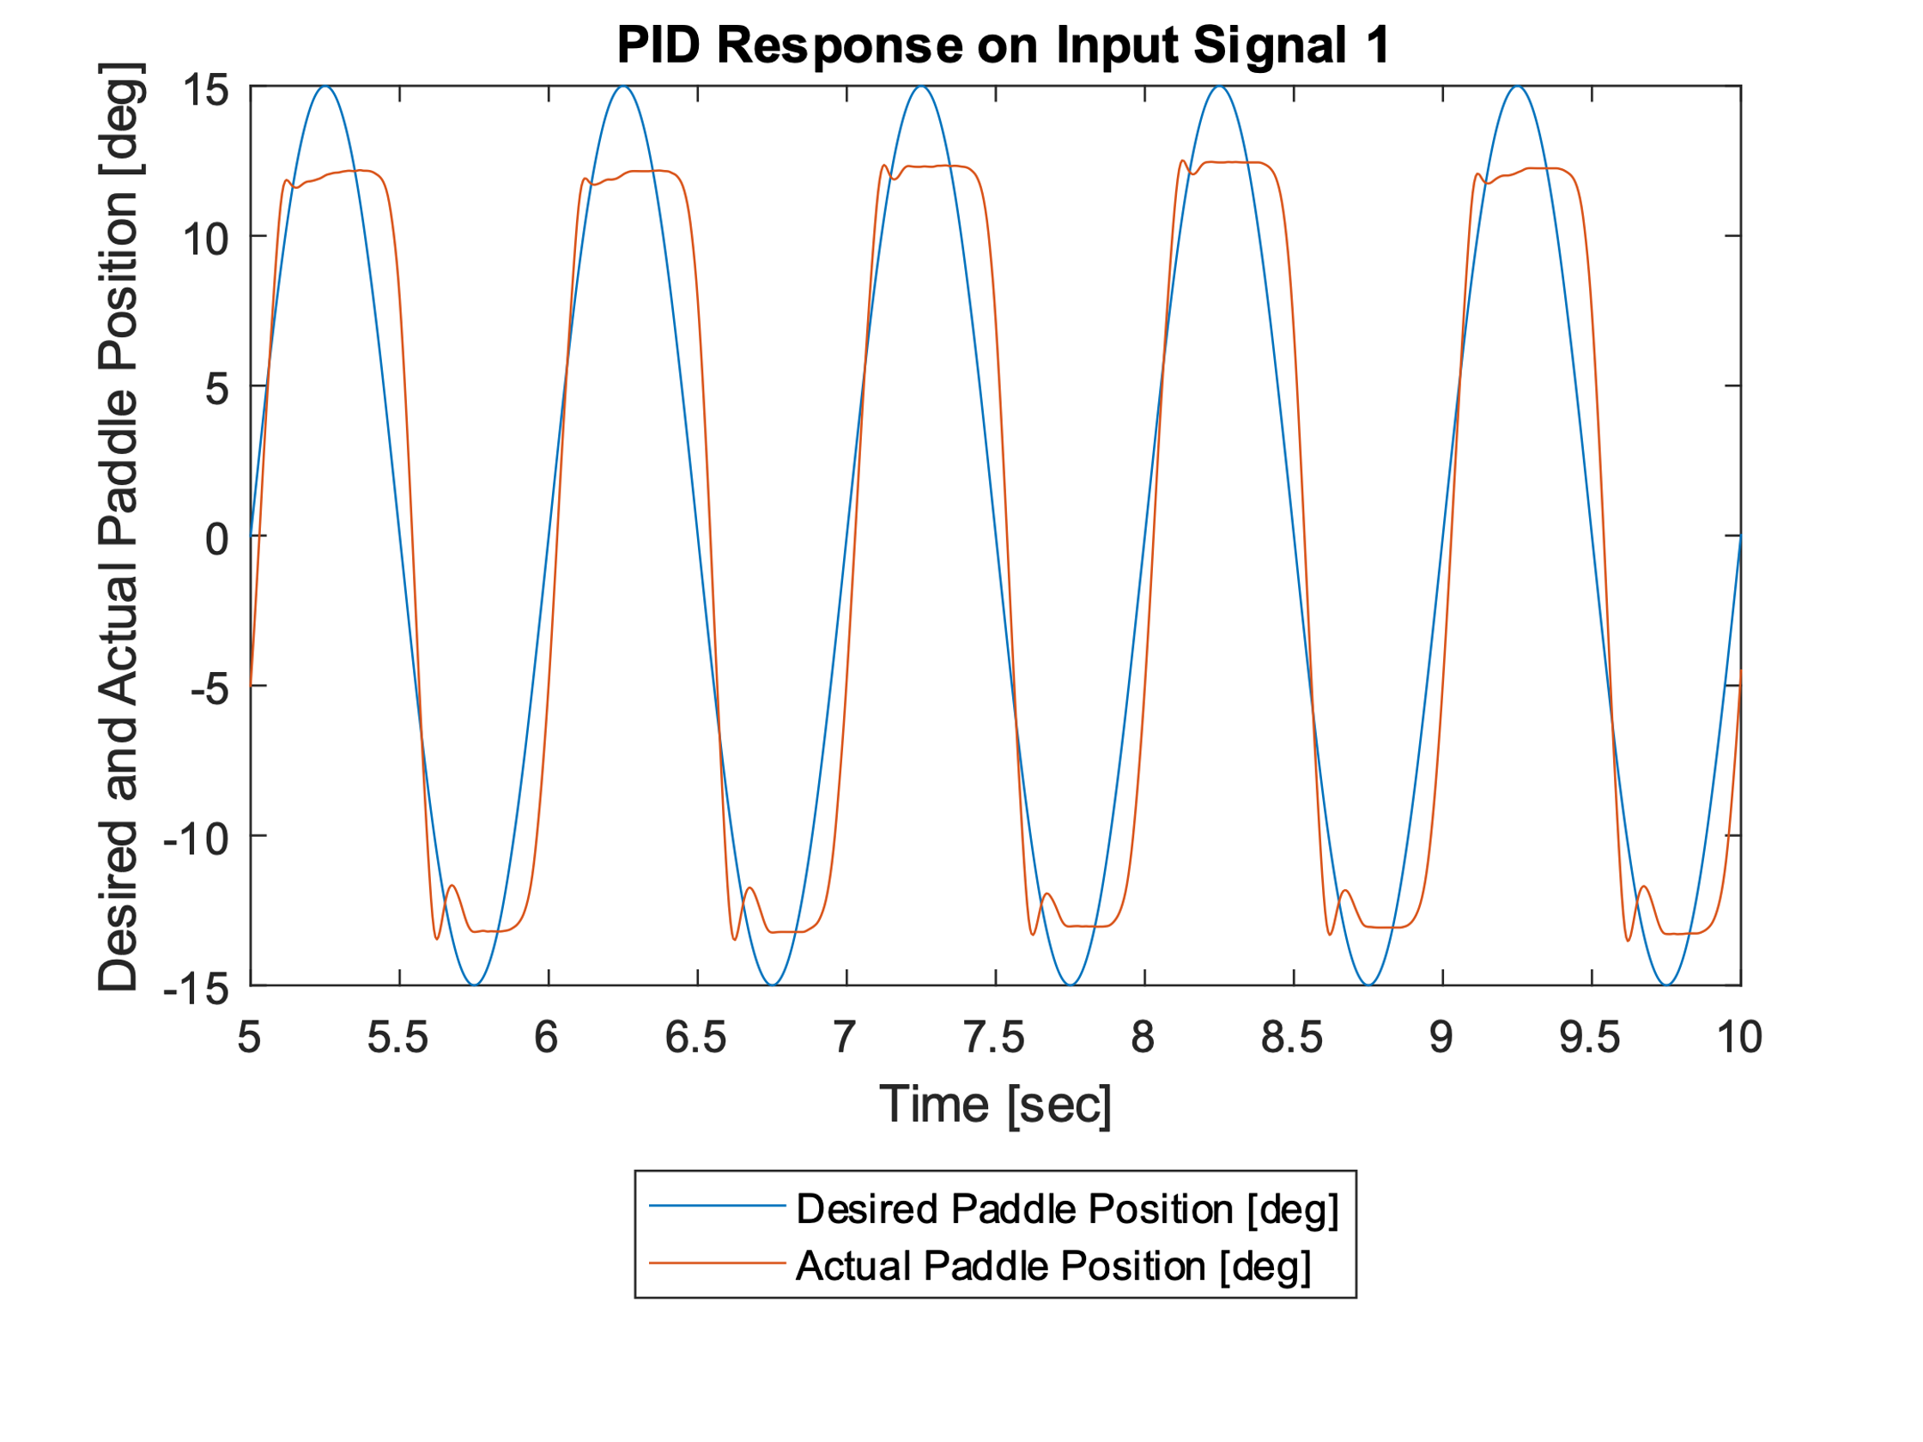

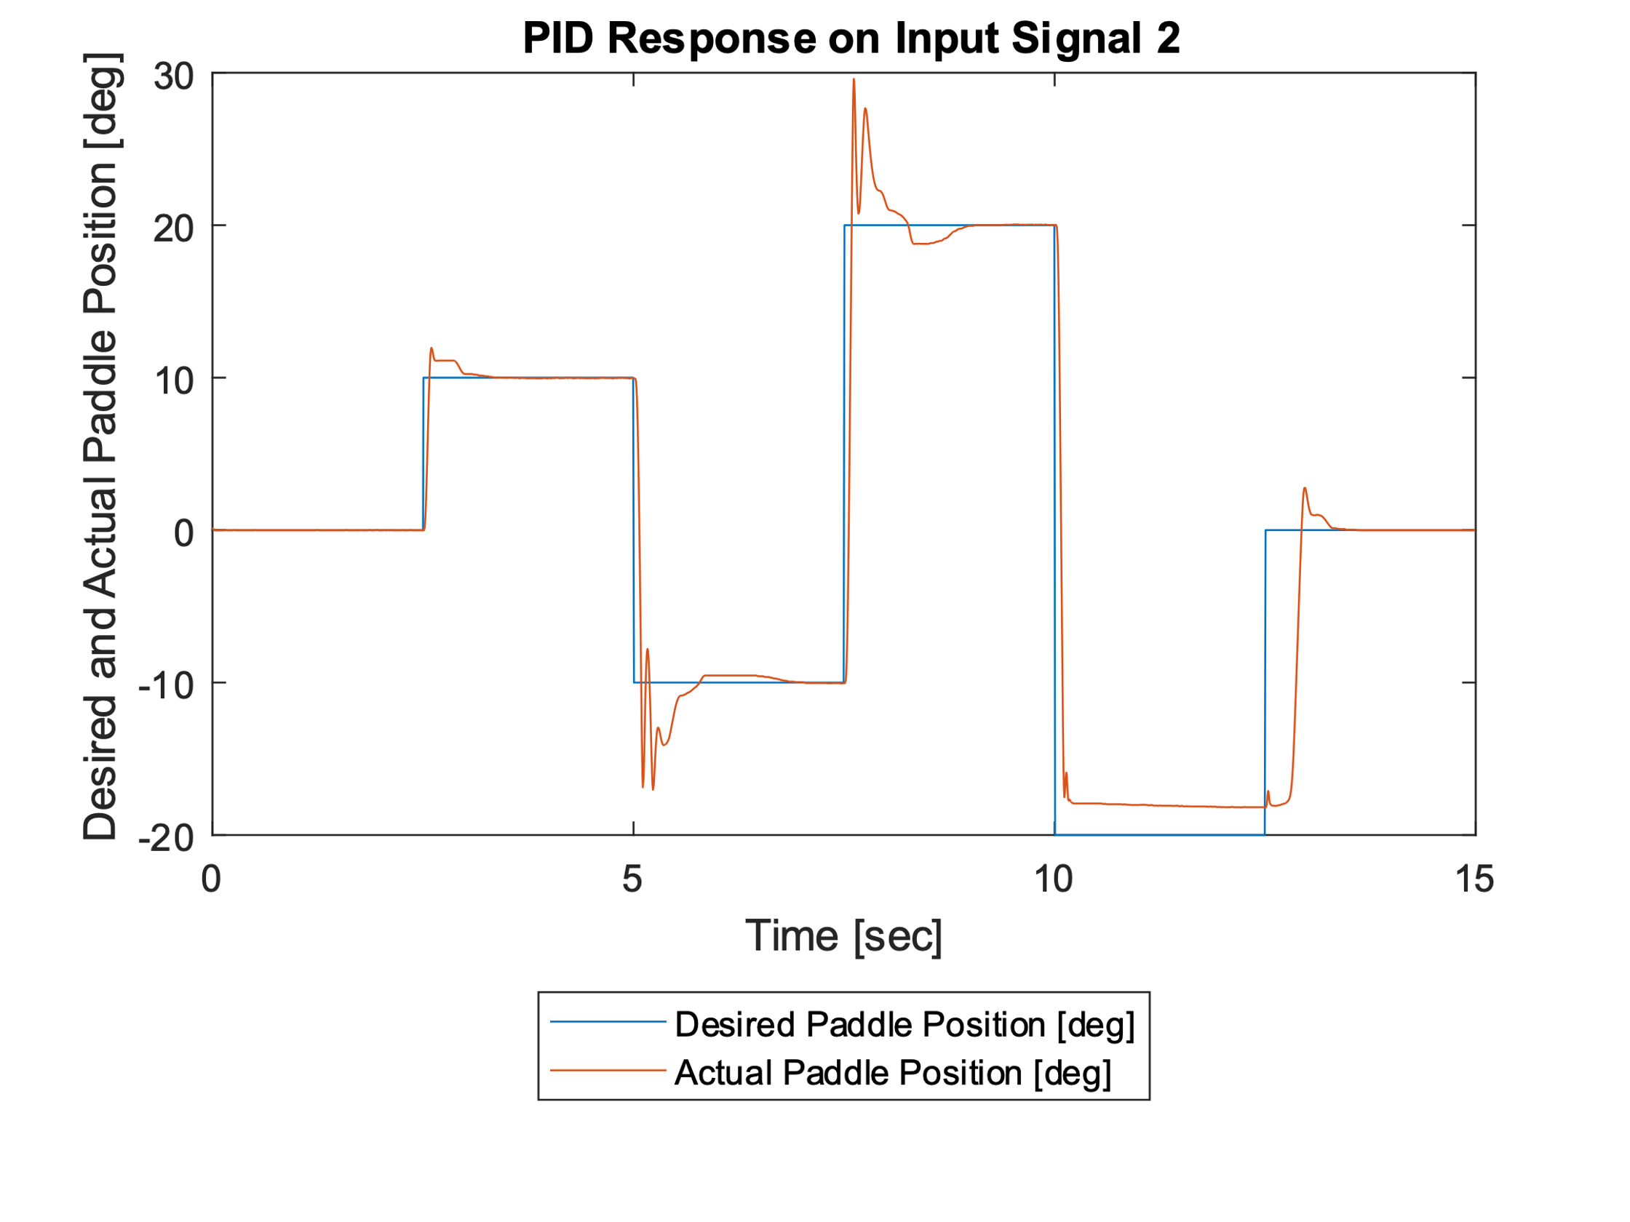

**PID response on signal 1 and signal 2. D-part acts on process variable**